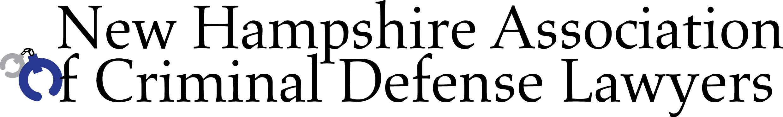

Experts and Annual Meeting

Friday, November 15, 2019
The Derryfield Country Club
625 Mammoth Road
Manchester, NH
Registration begins at 8 a.m. CLE starts at 8:30 am

The provider believes this course meets the requirements of NH Supreme Court Rule 53 for 360 minutes, including ethics/professionalism

This CLE is open to defense practitioners only.
Cost includes light breakfast, lunch and written materials via email. Materials are available on a flash drive for an extra $10. Register on-line at www.nhacdl.org or send the form below with a check.

Please register me for Experts and Annual Meeting, Manchester, NH

Name: ____________________________________________
Bar #: _______________
Email (PRINT clearly please):

___________________________________________________________
I have included: $155 ____ (NHACDL member) $265 _____ (nonmember)
$185 ____ (non-NH NACDL affiliate member) $10 ____ Flash drive

Please mail along with your check made payable to NHACDL to:
NHACDL, PO Box 8, Epping, NH 03042
Questions: katherine@nhacdl.org

